भारत मौसम विज्ञान विभाग |  | India Meteorological Department
Monday 04th May 2026 (14th Vaisakha 1948 Saka)
Summary of observations recorded at 0830 hours IST: The Western Disturbance as a cyclonic circulation over north Pakistan & neighbourhood at 3.1 km above m.s.l persisted. However, the trough aloft in middle and upper tropospheric westerlies with its axis at 5.8 km above m. s. l. ran roughly along Long. 72°E to the north of Lat. 28°N. The upper air cyclonic circulation over Haryana & neighbourhood extended upto 1.5 km above m. s. l.persisted A trough ran from above upper air cyclonic circulation over Haryana & neighbourhood to northeast Arabian sea across Rajasthan and Gujarat state and extended upto 1.5 km above m. s. l. The trough from above upper air cyclonic circulation over Haryana & neighbourhood to Southwest Rajasthan has merged with the above system. The upper air cyclonic circulation over East Madhya Pradesh & neighbourhood persisted and now extended upto 1.5 km above m. s. l. An upper air cyclonic circulation lies over interior Odisha & neighbourhood at 0.9 km above m. s. l. A trough runs from south Chhattisgarh to Manipur across the cyclonic circulation over interior Odisha & neighbourhood, Gangetic West Bengal and Meghalaya at 0.9 km above m. s. l. The north-south trough from South Chhattisgarh to Comorin Area now ran from Vidarbha to Comorin Area across Telangana, Rayalaseema and interior Tamil Nadu at 0.9 km above m. s. l. The upper air cyclonic circulation over Central Assam & neighbourhood lay over northeast Bangladesh at 1.5 km above m. s. l. The upper air cyclonic circulation over Southeast Rajasthan & neighbourhood became less marked.A fresh Western Disturbance is likely to affect Western Himalayan Region from 10th May, 2026. The east-west trough from Punjab to Nagaland extending upto 1.5 km above m. s. l. has become less marked.
Maximum Temperature Departures (as on 03-05-2026): markedly above normal(> 5.1°C) at few places over West Rajasthan, East Rajasthan and Coastal Andhra Pradesh & Yanam; at isolated places over Jammu KashmirLadakh-Gilgit-Baltistan-Muzaffarabad, East Madhya Pradesh, Chhattisgarh, Telangana, Tamil Nadu, Puducherry & Karaikal and North Interior Karnataka. appreciably above normal (3.1°C to 5.0°C) at many places over Vidarbha; at few places over Gujarat Region and Rayalaseema; at isolated places over West Uttar Pradesh, West Madhya Pradesh, Saurashtra & Kutch, Konkan & Goa, Marathwada and Kerala & Mahe. above normal (1.6°C to 3.0°C) at few places over Arunachal Pradesh, Madhya Maharashtra, Coastal Karnataka and Lakshadweep; at isolated places over Assam & Meghalaya, Punjab, Himachal Pradesh and South Interior Karnataka. near normal (-1.5°C to 1.5°C) at many places over Sub Himalayan West Bengal & Sikkim and Odisha; at most places over Andaman & Nicobar Islands and Haryana-Chandigarh-Delhi; at few places over Gangetic West Bengal and Jharkhand; at isolated places over East Uttar Pradesh. The highest maximum temperature of 44.8°C was reported at PHALODI-OBS (RAJASTHAN).
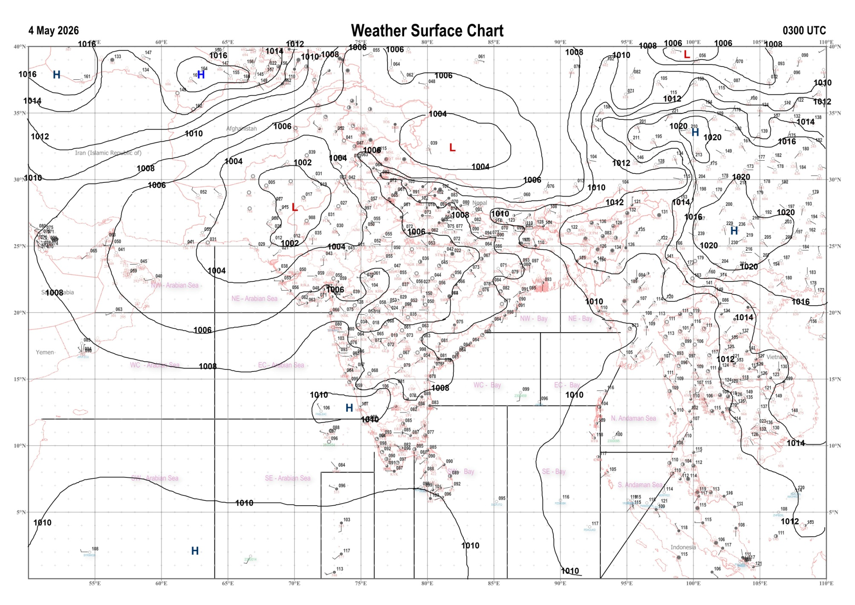 | 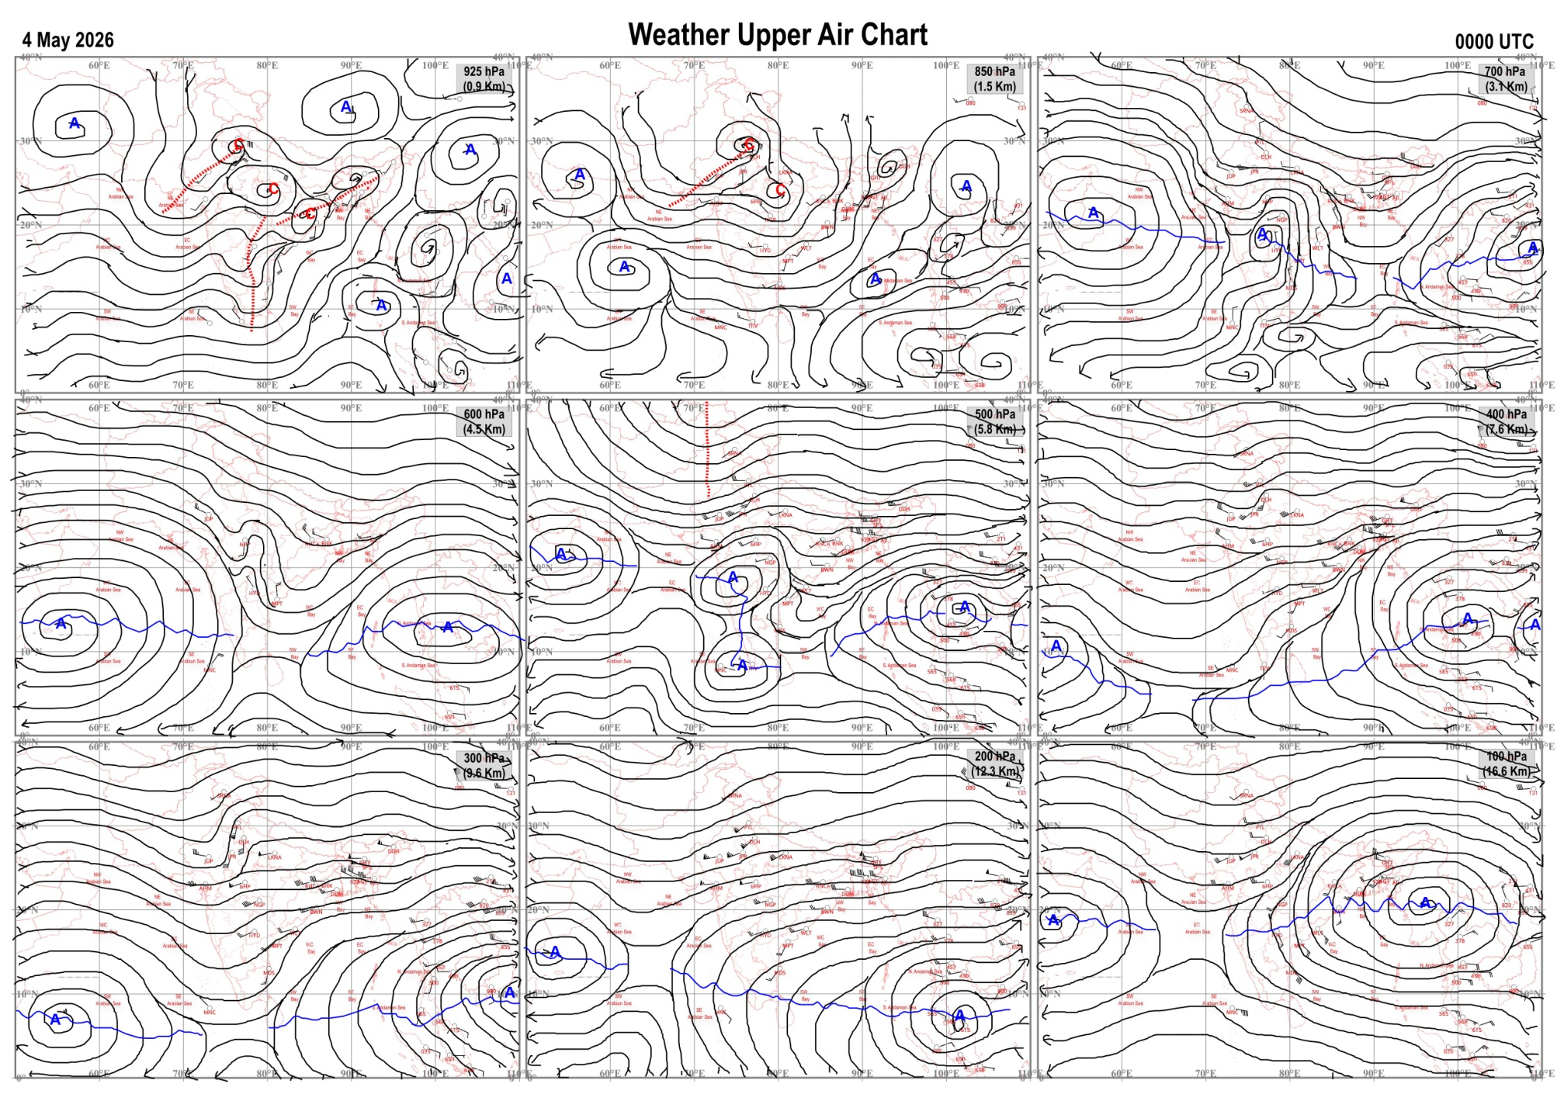
Fig.1. Analysed surface chart based on 03z observation | Fig.2. Analysed upper air chart based on 00z observation
V. K. Shripad
Scientific Officer ‘I’
CR & S Office, Pune  Issued at 1245 hrs. IST |  | Weather Forecasting Division  CR&S, Pune

Indian regions | Realised rainfall (chief amount in cm during past 24 hrs):
East | most places: Nagaland-Manipur-Mizoram-Tripura+  a few places: Assam & Meghalaya and Sub-Himalayan West Bengal & Sikkim+  isolated places: Arunachal Pradesh, Odisha+, Jharkhand and Bihar  dry weather: Gangetic West Bengal  Agartala AP & Met agartala AWS 8.7 each, Gandachara AWS 8.1, Chhatrapur 7.6, Kotpad 7.1, Rongo 6.8, Fagu tea estate 4.2, Kanti 3.3, Kalimpong 3.2, Marwan 3.0, Tenughat 2.2, Shella 1.9, Matijuri & Simdega 1.8 each, Bomdila AWS 1.5, Cherrapunji 1.4, Darbhanga 1.0, Tawang 0.9, Bomdila, Gopalpur & Ranchi AP 0.1 each.
North | most places: Uttarakhand and Haryana  many places: west Uttar Pradesh++ and Himachal Pradesh  isolated places: east Uttar Pradesh, Punjab, Jammu-Kashmir and Ladakh and Rajasthan  Gunnaur 13.0, Sahawar 9.7, Ndri kvk AWS 6.1, Bareilly PBO 5.5, Nainital 5.3, Pantnagar 5.1, Palliakalan 4.9, Srimadhopur 4.8, Renuka / dadhau 4.6, Mukteshwar 4.5, Hathinkundberaj AWS 3.9, Chhibramau & Hissar 3.3 each, Shahabad 3.2, Hardoi 3.1, Sangraha 3.0, Pilani 2.5, Khanna, Churu tehsil SR & Churu 1.8 each, Simla 1.7, Ballowal saunkri 1.4, Nowgam 0.8, Nohar SR 0.7, Patiala & Lolab 0.4 each, Gulmarg RS 0.1.
Central | isolated places: Madhya Pradesh and Chhattisgarh  dry weather: Vidarbha  Gadiras 2.2, Jabera 1.9, Seoni malwa 1.6, Lavkushnagar & Jagargunda 1.5 each, Damoh-aws 1.1, Sheopur-aws 0.9, Bhitarwar & Bilaspur 0.2 each.
Peninsula | isolated places: coastal Andhra Pradesh+, Telangana+, Rayalaseema, Tamil Nadu+, interior Karnataka and Kerala  dry weather: Gujarat State, Konkan & Goa, Madhya Maharashtra, Marathwada and coastal Karnataka  Amalapuram 8.7, Yercaud 6.8, Kusumanchi 6.7, Rasipuram 6.1, Racherla 5.8, Santhipuram 5.0, Anaimaduvu dam 4.5, Kakinada 4.1, Sambepalle 3.4, Mattampally 3.3, Hoskote 3.0, Arogyavaram 1.4, Bengaluru city 1.1, Ottapalam 0.9, Kundgol 0.5, Bengaluru kial 0.4, Kovilkadavu AWS 0.3, Khammam urban 0.2.
Islands | a few places: Andaman & Nicobar  dry weather: Lakshadweep  Maya bandar 0.8, Iaf carnicobar 0.5, Hut bay 0.3.
Table-2 Forecast / warnings (distribution of rain / thundershowers) for 7 days (valid from time of origin upto 0830 hrsIST of next day)
Sr N. |  | Sub-division Name | Day 1 | Day 2 | Day 3 | Day 4 | Day 5 | Day 6 | Day 7 | Sr. No. | Sub-division Name | Day 1 | Day 2 | Day 3 | Day 4 | Day 5 | Day 6 | Day 7
 |  |  | 04 May | 05 May | 06 May | 07 May | 08 May | 09 May | 10 May |  |  | 04 May | 05 May | 06 May | 07 May | 08 May | 09 May | 10 May
 | 1 | Andaman Nicobar Islands | S | S | I | S | S | S | S | 19 | west Madhya Pradesh | I  | I  | I  | I  | I  | I | D 
 | 2 | Arunachal Pradesh | W+  | F+  | F  | F  | S | S | S | 20 | east Madhya Pradesh | I  | I  | I  | I  | I  | I | I 
 | 3 | Assam-Meghalaya | F+  | F+  | F  | S  | S | S | F | 21 | Gujarat region | D | D | D | D | D | D + | D
 | 4 | Nagaland-Manipur-Mizoram-Tripura | F+  | F  | S  | S | I | I | I | 22 | Saurashtra and Kutch | D | D | D | D | D | D | D
 | 5 | Sub Him West Bengal/Sikkim | W+  | W+  | F+  | F  | S  | S | I  | 23 | Konkan and Goa | D | D | D + | D + | I + | D | D +
 | 6 | Gangetic West Bengal | W+  | W  | F  | F  | S  | S | I  | 24 | Madhya Maharashtra | D | D | D | I  | I  | D | D
 | 7 | Odisha | S+  | S+ | S  | I  | I  | I | I  | 25 | Marathwada | D | D | I  | I  | I | D | D
 | 8 | Jharkhand | F  | F+  | S  | S  | S  | S  | I  | 26 | Vidarbha | I  | I  | I  | I  | D | D | D
 | 9 | Bihar | F+  | I  | S+  | I  | I  | I | I  | 27 | Chhattisgarh | I  | S  | S  | I  | I  | I | I 
 | 10 | east Uttar Pradesh | F+  | F  | S  | S  | S | I | I | 28 | Coastal Andhra Pradesh and Yanam | S+  + | S+  + | S  + | S  | I  | I | I 
 | 11 | west Uttar Pradesh | F+  | S  | S  | I | I | I | D | 29 | Telangana | I  | I  | S  | S  | I  | I | I 
 | 12 | Uttarakhand | W+  | F  | F  | S  | S  | I | I  | 30 | Rayalaseema | I  | I  | I  | I  | I  | I | I 
 | 13 | Haryana,Chandigarh and Delhi | F  | S  | I  | I | D | D | I | 31 | Tamil Nadu, Puducherry and Karaikal | I+ + | I | I | S | S | S | S
 | 14 | Punjab | F  | I  | I  | I | D | D | I | 32 | Coastal Karnataka | I | I | I | I | I | I | I
 | 15 | Himachal Pradesh | F  | F  | S  | I | I | I | S | 33 | North interior Karnataka | I | I | I | I | I | I | I
 | 16 | Jammu-Kashmir and Ladakh | F  | S  | I  | I | I | D | D | 34 | South interior Karnataka | I | I | I+  | S+  | S | S | S
 | 17 | west Rajasthan | I  | I  | I  | I  | D | D | D | 35 | Kerala and Mahe | F+  | S  | S+  | F  | F+  | F | F+
 | 18 | east Rajasthan | I  | I  | I  | I  | I  | D | D  | 36 | Lakshadweep | S | S | S | S | S | S | S
Legends: D = Dry I =isolated S = Scattered F = Fairly widespread W = Widespread #= heavy to very heavy rain at a few places with extremely heavy rain at isolated places+++= heavy rain at a few places with very heavy rain at isoIated places++= heavy to very heavy rainfall @=isolated exceptionally heavy rainfall+ = heavy rain ●/*= rain or snow ♦ = very light rain ≡=fog = thunderstorm with lightning =Squall / Gusty / gale / strong wind -=cold wave/cold day + = heat wave/warm night/hot and humid weather =Duststorm =ground frost = Hail.

Fig. 4: Districtwise warnings for five days for Maharashtra State
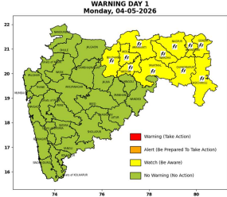 | 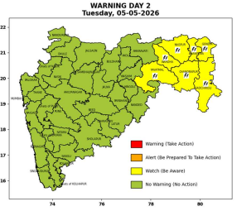 | 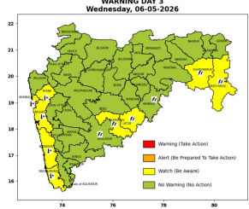 | 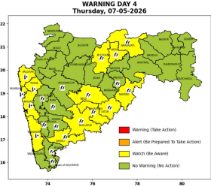 | 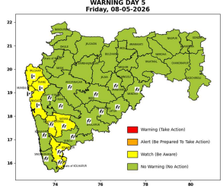

Pune, Lohegaon and Pashan observations at 0830 hrs. IST of Today
 | Temperature (°C) |  |  |  |  | Humidity (%) |  |  |  | Rainfall (mm)
 | Max.  past  24 hrs | Dep.  from  normal | Min.  past  24 hrs. | Dep.  from  normal | Dry  Bulb | At 0830 hrs. IST | Dep.  From  normal | At 1730  hrs. IST of y’day | Dep.  from  normal | Past  24 hrs. | Since  1st March | Dep.  from  normal
PNE | 38.3 | -0.2 | 22.6 | 1.0 | 27.0 | 61 | 11 | 29 | 1 | 0.0 | 92.8 | 75.3
PSN | - | - | - | - | - | - | - | - | - | - | - | -
LHG | 40.0 | 2.0 | 23.7 | 2.7 | 29.5 | 48 | -5 | 18 | -9 | 0.0 | 91.4 | -

 |  |  |  |  |  |  | Local (Pune and neighbourhood) forecast
Max./Min. Temperature (°C) |  |  |  |  |  |  |  |  | Weather
Date | Pune | Pashan | Lohegaon | Chinchwad | Lavale | Magarpatta | NDA | Koregoan park
04/05/26 | 38 / 22.6* | 37 / - | 39 / 23.7* | 37 / * | 37 /-- * | 38 / -* | 37 /20.3* | 38 / -* | Mainly clear sky.
05/05/26 | 38 / 23 | 37 / 23 | 39 / 24 | 37 / 24 | 37 / 20 | 38 / 25 | 37 / 20 | 38 / 25 | Mainly clear sky.
06/05/26 | 38 / 23 | 37 / 23 | 39 / 24 | 37 / 24 | 37 / 20 | 38 / 25 | 37 / 20 | 38 / 25 | Mainly clear sky.
07/05/26 | 39 / 23 | 38 / 23 | 40 / 24 | 38 / 24 | 38 / 20 | 39 / 25 | 38 / 20 | 39 / 25 | Mainly clear sky
08/05/26 | 39 / 24 | 38 / 24 | 40 / 25 | 38 / 25 | 38 / 21 | 39 / 26 | 38 / 21 | 39 / 26 | Mainly clear sky
09/05/26 | 40 / 24 | 39 / 24 | 41 / 25 | 39 / 25 | 39 / 21 | 40 / 26 | 39 / 21 | 40 / 26 | Mainly clear sky
10/05/26 | 40 / 24 | 39 / 24 | 41 / 25 | 39 / 25 | 39 / 21 | 40 / 26 | 39 / 21 | 40 / 26 | Mainly clear sky
Rainfall Distribution |  |  |  |  | Rainfall Categories | Rainfall (mm) | Cloud condition |  | Rainfall Intensity | Range
Widespread (W) | 76-100% |  |  |  | Very Light rain | Trace to 2.4 mm | Mainly clear sky | 1-2 oktas | Light Spell | 1 cm/hr
 |  |  |  |  | Light rain | 2.5 to 15.5 mm | Partly cloudy sky | 3-4 oktas | Moderate Spell | 1-2 cm/hr
Fairly Widespread (FW) | 51 – 75% |  |  |  | Moderate rain | 15.6 to 64.4 mm | Generally cloudy sky | 5-7 oktas | Intense Spell | 2-3 cm/hr
Scattered (S) | 26 – 50% |  |  |  | Heavy rain | 64.5 to 115.5 mm | Overcast | 8 oktas | Very Intense Spell | 3-5 cm/hr
Isolated (I) | 1 – 25% |  |  |  | Very heavy rain | 115.6 to 204.4 mm |  |  | Extremely Intense Spell | 5-10 cm/hr
Dry (D) | No Rain |  |  |  | Extremely heavy rain | ≥ 204.5 mm |  |  | Cloudburst | > 10 cm/hr
Probability Terms in %: |  |  |  |  | Heavy snow | 6.5 to 11.5 cms water equivalent of rain
unlikely | < 25 |  |  |  | Very heavy snow | 11.6 to 20.4 cms water equivalent of rain
likely | between 25 50
very likely | between 51 75
most likely | >75
* = realized temperatu
Mumbai (Colaba) |  |  |  | Nagpur (AP)
Date 2026 | T max °C | T min °C | Weather | T max °C | T min °C | Weather
04/05/26 | 35 | 27 | Partly cloudy sky. | 43 | 25 | Thunderstorm with rain. Thunderstorm accompanied with lightning & gusty winds(40-50 kmph).
05/05/26 | 35 | 26 | Partly cloudy sky. | 42 | 25 | Thunderstorm with rain. Thunderstorm accompanied with lightning & gusty winds(40-50 kmph).
06/05/26 | 36 | 26 | Clear sky. Hot and Humid. | 43 | 26 | Thunderstorm with rain
07/05/26 | 36 | 27 | Clear sky. Hot and Humid. | 44 | 28 | Mainly clear sky.
08/05/26 | 36 | 27 | Clear sky. Hot and Humid. | 43 | 26 | Mainly clear sky.
09/05/26 | 35 | 28 | Mainly clear sky | 44 | 26 | Partly cloudy sky.
10/05/26 | 35 | 28 | Mainly clear sky. | 43 | 26 | Mainly clear sky.

